**642 Final Project**

**Dan Huang**

**Maximization for the Longest Distance of Catapult**

**1. Introduction**

The report of this design of experiment mainly focuses on maximizing the furthest distance of catapult under seven factors. We began with initial factional factorial design to study the effects of seven two-level factors to identify which factors affect the primary responses. It’s economic for the experimenters to increase the number of factors or increase the resolution for promoting the directions of improvement. A full factorial design would require no less than 128 runs. In practice, running seven predictive variables is very common but conducting 128 runs might be very costly and hard to justify. Fractional factorial designs are very popular; in our case, we collected a fourth fraction of full factorial design as the initial fractional design, which greatly reduced costs and time needed for an experiment although a full factorial design is the most desirable design where we could gather information on all main effects, two-factor interactions and higher order interaction.

**2. Election of Factors and Data Collection**

In our experiment, it included seven factors containing five quantitative factors that are on catapult and two qualitative factors.

|  |  |  |  |  |  |  |  |
| --- | --- | --- | --- | --- | --- | --- | --- |
| **Factorial Level** | **(A)**  **Cup Factor** | **(B)**  **Rubber band - Cup Side** | **(C)**  **Release Pin** | **(D)**  **Rubber band Tautness** | **(E)**  **Arm Angle** | **(F)**  **Candy Type** | **(G)**  **Catapult Height** |
| Low  (-1) | 1 | 4 | 3 | 1 | 160o | Brown Hershey’s  (around 5g) | Floor  (0cm) |
| High  (1) | 3 | 6 | 4 | 4 | 180o | Snicker’s  (around 10g) | Desk  (around 30cm) |

On April 5th ,2018, we collected 32 runs initial fractional factorial design with seven factors at two levels and without replicates and blocks by using body scale measurement. On April 20th, 2018, we collected additional 32 runs fold-over design by using same measurement, same desk, same two candy types we used before at same location. In this experiment, we have three operators: one is to read the distance and launch the catapult; one is to record the data; one is to adjust different levels with different factors.

3. Design Methods

a) Fractional Factorial Design

fractional factorial design allows us to investigate the effects of many factors in subset fraction runs rather than a full factorial design. There are some benefits to perform many factors with fractional factorial design. Firstly, fractional factorial design is convenient to increase the number of factors instead of number of runs that will take more time and cost. In this case, we chose 7 factors in one fourth the number of runs required by a full factorial for this experiment. Since a successful experiment includes important factors, it’s more useful to investigate 7 factors’ influence rather than six or five without adding additional runs. Secondly, factional factorial design estimates the relevant effects in the simple model where the true situation can be described correctly. Conducting this fourth fraction of full factorial did not cause much confusion when the results were analyzed in this experiment of the analysis. Although the fraction factorial design is not so perfect, the simple model included can explain most of the total variability and we examine some aspects corresponding to how to increase the response. Thirdly, in our experiment, one of the variables examined seemed to be less significant. In such case, we don’t need to conduct a full factorial design in all of the factors when experimenting with many factors. Finally, we can always take the follow-up designs into account from what we learn from the initial fractional factorial design. In our experiment, we augmented our initial fractional factorial design to fold-over design by switching one column in a new region. In fractional factorial design, there are two assumptions:

Important effects “sparsity”: the number of relatively important effects are small;

Important effects “simplicity”: main effects and/or two-factor interactions are more likely to be important than higher-order interactions, which is also known as hierarchy principle.

b) Fold-over Design

It’s particularly important for fractional factorial designs to do follow-up experimentation since the assumption that certain factorial effects can be ignored is involved in the estimation of a model from fractional factorial design. Regular resolution IV fractional factorial designs partially alias some two-factor interactions, a common follow-up to a resolution IV is to add another fraction by switching single column. Fold-over is the term to describe increasing the resolution by switching columns that differ from the original fraction for one or more factors. There are some benefits to augment the initial resolution IV with its mirror image fraction: all two-factor interaction estimates become clear of aliasing with other two-factor interactions; combination of two-factor interactions formerly aliased with other two-factor interactions are now estimable; the precision of all estimates could be improved. There is an implicit assumption that the effects are stable from the first fraction to the second fraction by performing a fold-over design. Otherwise, the instability of some effects would be incorrectly attributed to the interactions aliased with the two-factor interactions in the original fraction. For resolution IV designs, we only reverse single column of the factor sign and so increase the resolution to V.

Admittedly, in our experiment, resolution IV fractional factorial design typically might have only few statistically significant estimates involved in the strings of aliased. Here, the ambiguity concerned a single pair of two-factor interactions and two main effects were significant in previous design. Therefore, we switched the F column by adding another complete fraction compare to the original fractional factorial design.

4. Detailed Analysis

4.1 Initial Fractional Factorial Analysis

Step 1: plot the response data

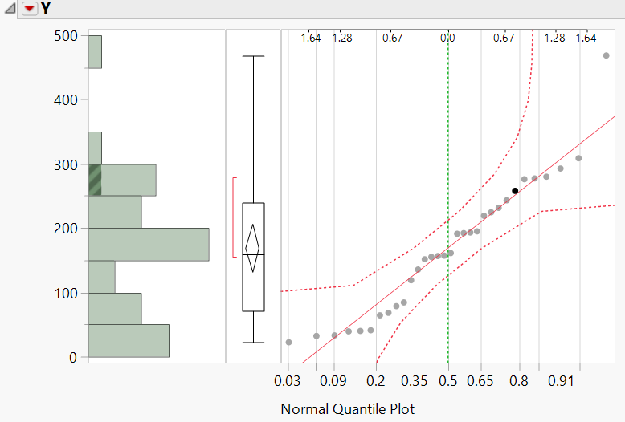

The thorough analysis requires building models to get the maximum distance via identifying the sufficient variables with furthest distance. Looking at the histogram of yield, it’s easy to notice that the data values with yield <300 will dominate because they represent most of the variation. Since we are interested in higher values for yield, it could be understandable to fit a model for transformation that compresses value for low yield and spreads out the values for high yield. One reasonable choice would take log of yield as the new response. Here, we took log transformation of Y to analyze the data and decided to analyze the reduced model with Log Y as well.

Step 2: Determine resolution, aliasing and effects that can be estimated

This experiment is one-fourth fraction, so the defining relation contains four terms. The two generators create the length-4 CDEF and length-5 words ABDEG. F=CDE, G=ABDE

I= CDEF=ABDEG=ABCFG

This is a resolution IV design with one length-4 word and two length-5 words, two more than the minimum aberration 27-2 design. Given the defining relation, we now identify which (combinations of) effects can be estimated. Fitting a model containing all seven main effects and 21 two-factor interactions results in the following linear dependencies among the columns of the model matrix: CD=EF, CE=DF, CF=DE. Thus, with this experiment, we can estimate seven main effects and 18 two-factor interactions, assuming three-factor and higher-order interactions are negligible. The remaining six degrees of freedom may be used to estimate the error variance, as well as check the assumption of no higher-order interactions.

The two- factor interactions in the model are AF=BCG=ACDE=BDEFG; BF=ACG=BCDE=ADEFG; CG=ABF=DEFG=ABCDE; CF=DE=ABG=ABCDEFG; BG=ACF=ADE=BCDEFG; AG=BCF=BDE=ACDEFG; CE=DF=ABCDG=ABEFG; AE=BDG=ACDF=BCEFG; BE=ADG=BCDF=ACEFG; DG=ABE=CEFG=ABCDF; CD=EF=ABCEG=ABDFG; AD=BEG=ACEF=BCDFG; BD=AEG=BCEF=ACDFG; EG=ABD=CDFG=ABCEF; AC=ADEF=BFG=BCDEG; BC=AFG=BDEF=ACDEG; FG=ABC=CDEG=ABDEF; AB=CFG=DEG=ABCDEF

Step 3: Fit a saturated model and use output to select a tentative reduced model

For most fractional factorial designs, including this resolution IV 27-2, the simplest way to fit a saturated model is to specify a full factorial model in the basic factors. Fitting a saturated model for experiments without replication will produce an estimate for the standard error of each coefficient via Lenth’s PSE method based only on an assumption of the sparsity of important effects. After identifying the number of significant effects, we can use the defining relation and the corresponding aliasing to interpret which effects in each important alias set is most plausibly present. We now illustrate these steps for the response log of yield. A Pareto plot of 31 effect estimates is shown in Figure below. In our analysis, we need to consider that each of these terms has three aliases, which we will take into account after determining which estimates are large enough to be included in the reduced model.

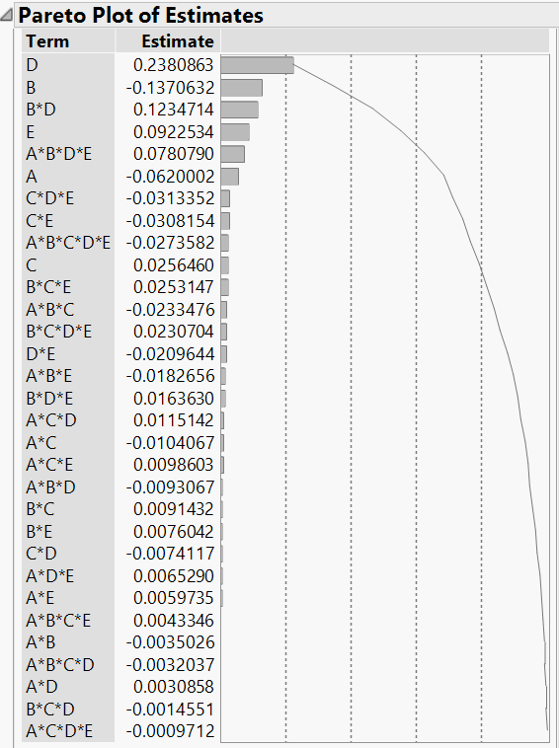

Using Lenth’s t statistics method: s0=1.5*median (0.016363) =0.045445; remove all |β|>2.5*s0=0.06136125; PSE=1.5*new median (0.0098603) =0.01479045; ME=2.064 * PSE= 0.0305. Thus, we know eight effects are found to be statistically significant at four main effects A, B, D, E and two-factor interactions BD, CE; three-factor interaction CDE and four-factor interaction ABDE. However, F=CDE, G=ABDE=ABCF=CDEFG in the aliasing. And CE=DF=ABCDG=ABEFG in the aliases. So, we could include G and F to analyze in our model instead of CDE and ABDE. Because of the dominance of the main effects for A, B, D, E and G, we consider the significant estimate associated with the aliases BD=AEG=BCEF=ACDFG; CE=DF as evidence for the two-factor interactions BD and CE. Therefore, we will keep BD in our model. Since main effect D and E were shown in pareto diagram that were significant, neither C and F are themselves significant. It’s risky to separate CE and DF but F=CDE and CDE is significant. So, we keep F and DF in the model as well because of the hierarchy principle that when two interactions are confounded with one another, the interaction that is the most likely to be significant is the one containing factors whose main effects are themselves significant.

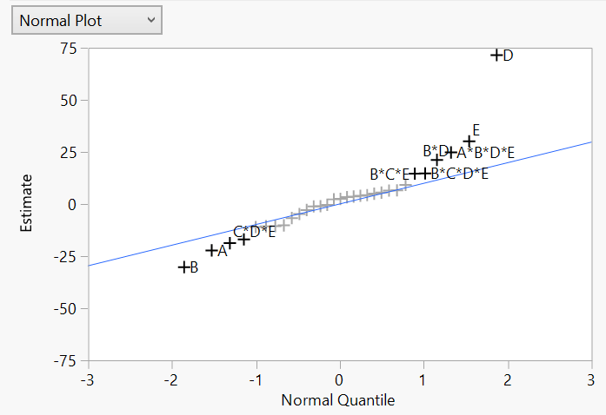

From the normal plot, A, B, D and E four main effects are significant and standing out from the line. Also, we notice that some interactions BD, BCE, CDE, ABDE and BCDE appear important but we consider the significant estimate associated with the aliases BD=AEG=BCEF=ACDFG; BCE=BDF=ACDG=AEFG; F=CDE=ABCG=ABDEFG; G=ABDE=ABCF=CDEFG; BF=ACG=BCDE=ADEFG. Thus, we will include main effects F, G, two-factor interactions BF, BD and three-factor interaction BDF because we have three main effects B, D and F in the model. To ensure that our model is hierarchical, inclusion of BDF in the model requires that we need to add DF in the model as well.

Using the 0.05 level of significance, we would include six of the seven main effects A, B, D, E, F, G, two-factor interactions BD, BF, DF and three-factor interaction BDF as our reduced model.

Step 4: Examine fit and diagnostics for the reduced model; consider modifications until a satisfactory summary is obtained.

a) This model has R2= 97%, which means 97% of the variability is explained by the estimates in the model. The ANOVA table tells us there is significant difference on mean of the log of yield. A residual versus predicted plot from this proposed reduced model indicates that the assumption of constant variability across the range of predicted responses appears good. Next, we plot residuals distribution to check on independence of the error distribution, which shows good. So, this reduced model appears to be satisfactory. From the parameter estimate table, we could know that BF and BDF are not significant in this model. The effect tests table also gives us the evidence that BF and BDF are not significant in this model.

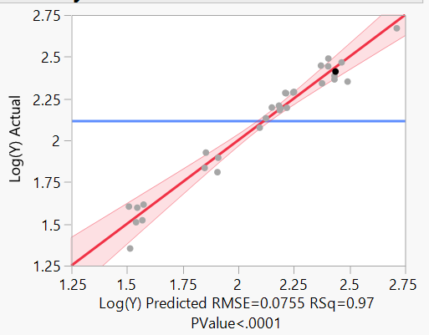

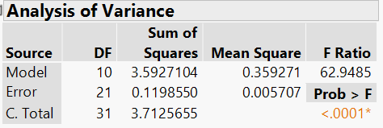

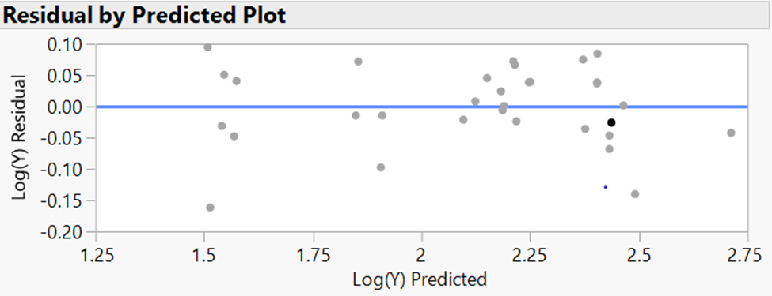

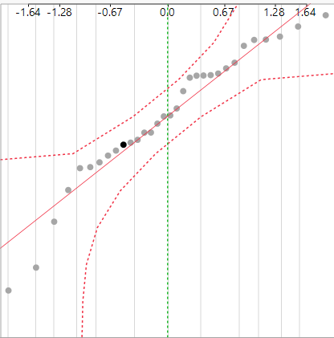

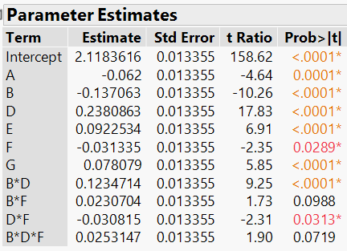

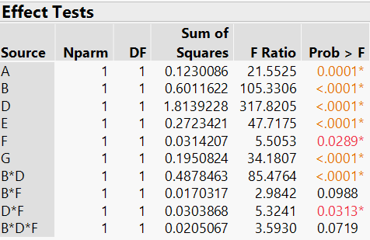

b) Now, we need to fit this reduced model again by removing BF and BDF estimates.

This model has R2=0.96, which means 96% of the variability is explained by the estimates in this model. A residual versus predicted plot from this proposed reduced model indicates that the assumption of constant variability across the range of predicted responses appears good. Next, we plot residuals distribution to check on independence of the error distribution, which shows good. So, this reduced model appears to be satisfactory. The ANOVA table tells us there is significant difference on mean of the log of yield. As expected, rubbed band tautness (D) and arm angle (E) increases distance due to tensile strength and the addition of cup factor (A), rubber band cup side (B) and candy type (F) decrease the distance as well as the weighted candy. The predicted values here represent the expected log(Y), averaging over the levels of the other factors. When changing from low level to high level with A with other variables held constant, the distance will decrease since we lowered the height for the catapult to throw the candy. Similarly, changing from low level to high level with B is to lower the height to launch the candy, which shortens the distance. As we increase the candy type 5g to 10g, the highly weighted candy decreases the distance.

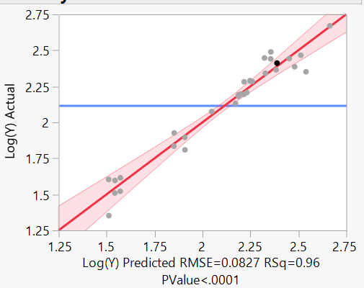

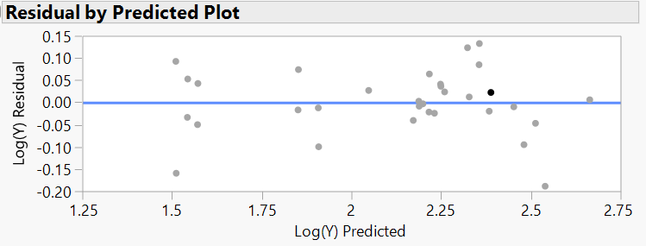

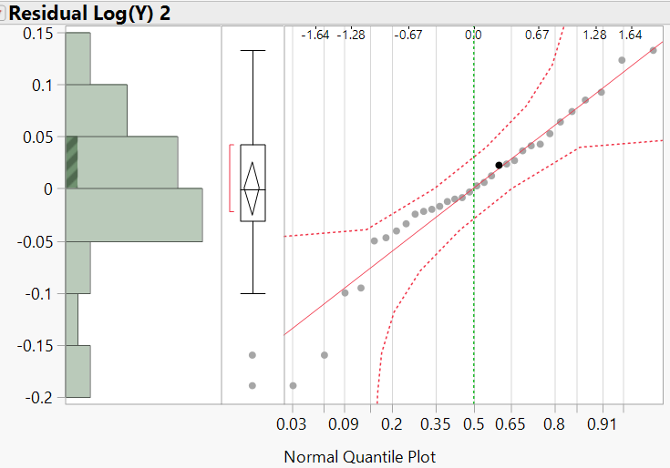

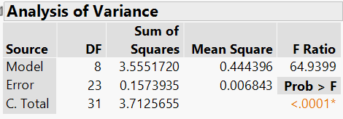

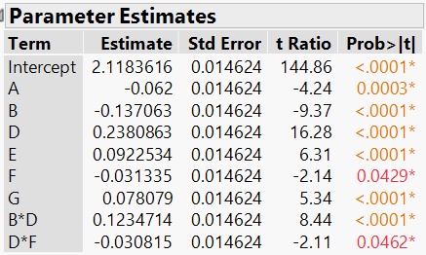

c) Another solution for this model is we can take Yield directly as the response with main effects A, B, D, E, F, G, BD and DF. This model has R2=0.88, which shows 88% of the variability is explained by the variables in the model. ANOVA table tells us that there is significant difference on mean yield. The parameter estimate table shows the reduced model is

Y=168.41-22.02A-30.03B+71.75D+30.38E-18.53F+25.03G+21.44BD-16.73DF

Result: The fitted model above indicates that the response will decrease as we change A, B from low level and high level, which makes perfect sense; changing D, E and G from low level to high level will increase the response, which is our expectation. Exchanging the experiment unit from low weight to high weight will decrease the response as it’s shown the sign of F.

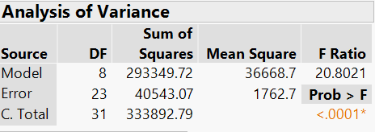

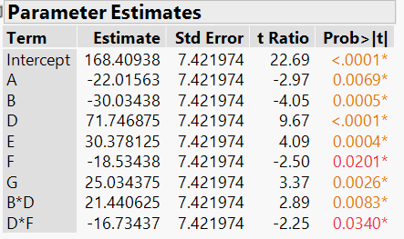

4.2 Second fractional factorial design

Fold-over by switch the column F: F=-CDE

To demonstrate the main ideas of this part, the generators F=CDE and G=ABDE in the initial fractional design. This fraction has a length-four word and two length-five in its defining relation. The generator for the mirror image fraction is F=-CDE and G=ABDE. Hence, we can get the mirror-image fraction by reversing the column F. Since we collected the data in different days, I included block as a main effect in the combined data.

Now the complete defining relation for this fold-over design is I=-CDEF=ABDEG=-ABCFG.

4.2.1 using only the fold-over design data

Step 1: plot the response data

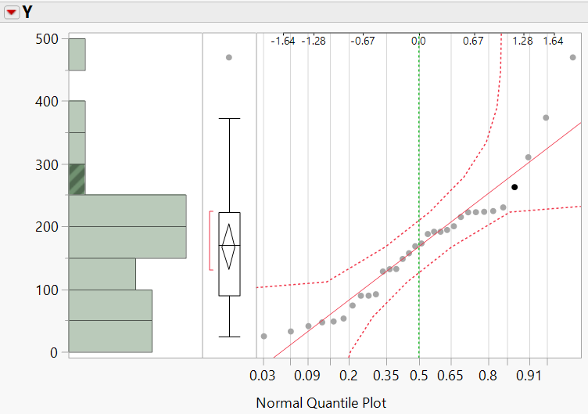

Since we are interested in higher values for yield, it could be understandable to fit a model for transformation that compresses value for low yield and spreads out the values for high yield. One reasonable choice would take log of yield as the new response. Here, we took log transformation of Y to analyze the data and decided to analyze the reduced model with log Y.

Step 2: Fit a saturated model and use output to select a tentative reduced model

Using Lenth’s t statistics method: s0=1.5* median (0.0098277) =0.01474155; remove all |β|>2.5*s0=0.03685; PSE=1.5*new median (0.0094454+0.0094203/2) =0.014149275; ME=2.064 * PSE= 0.0292. Thus, we know seven effects are found to be statistically significant at four main effects A, B, D, E and interactions BD, CDE and ABDE. However, G=ABDE=ABCF=CDEFG; BD=AEG=-BCEF=-ACDFG; -F=CDE=ABCG=-ABDEFG in the aliasing. So, we could include A, B, D, E, G, F and BD to analyze in our model.

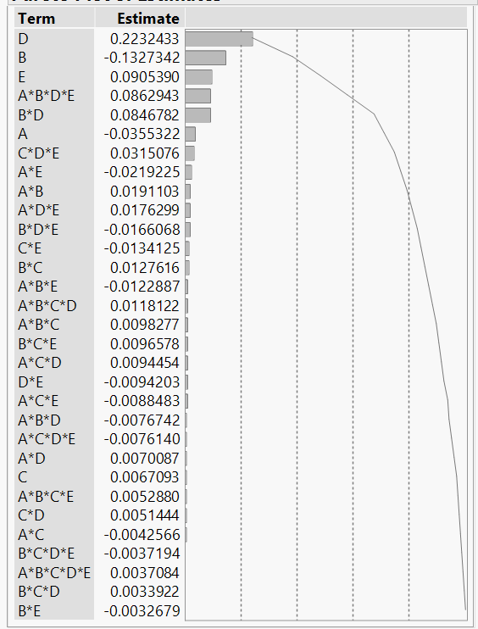

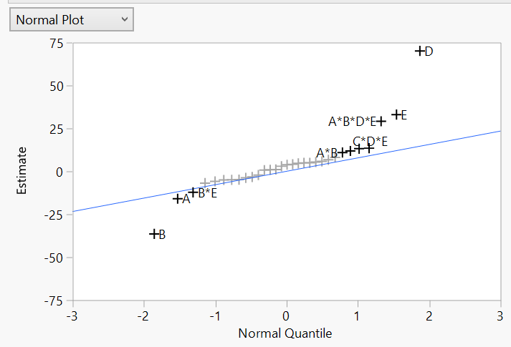

From the normal plot, A, B, D and E four main effects are significant and standing out from the line. Also, we notice that some interactions AB, BE, CDE and ABDE appear important but we consider the significant estimate associated with the aliases AB=-CFG=DEG=-ABCDEF; BE=ADG=-BCDF=-ACEFG; F=-CDE=-ABCG=ABDEFG; G=ABDE=-ABCF=-CDEFG. Thus, we will include main effects F, G, two-factor interactions AB and BE in the model because of sparsity principle and hierarchy principle.

Overall, main effects A, B, D, E, F, G and two-factor interactions AB, BE, and BD will be included in the model.

Step 3: Examine fit and diagnostics for the reduced model; consider modifications until a satisfactory summary is obtained.

a) This model has R2= 97%, which means 97% of the variability is explained by the estimates in the model. The ANOVA table tells us there is significant difference on mean of the log of yield. A residual versus predicted plot from this proposed reduced model indicates that the assumption of constant variability across the range of predicted responses appears good. Next, we plot residuals distribution to check on independence of the error distribution, which shows good. So, this reduced model appears to be satisfactory. From the parameter estimate table, we could know that two-factor interactions AB and BE are not significant in this model. The effect tests table also gives us the evidence that AB and BE are not significant in this model.

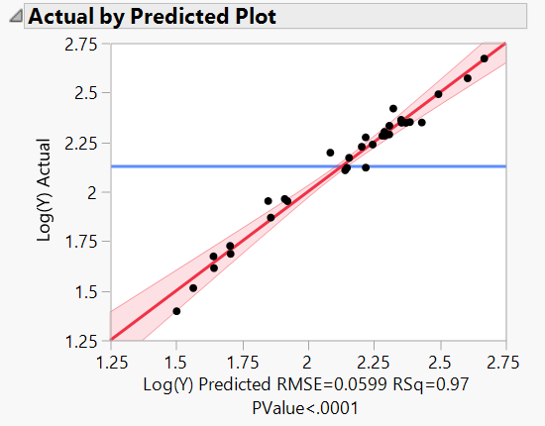

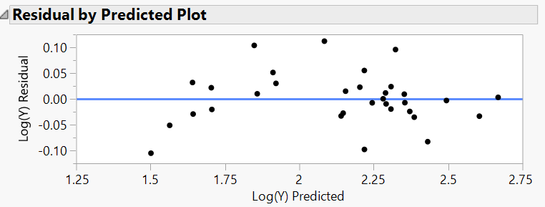

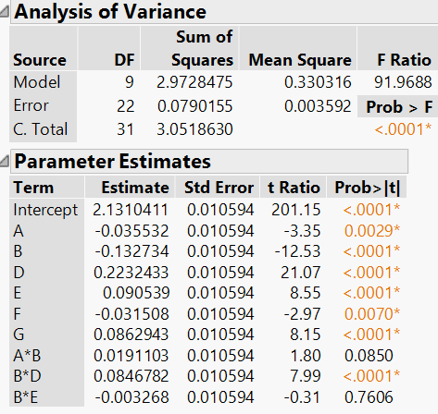

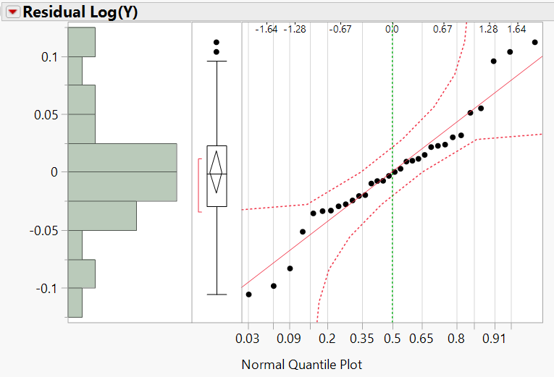

b) Now, we need to fit this reduced model again by removing AB and BE estimates.

This model has R2= 97%, which means 97% of the variability is explained by the estimates in the model. The ANOVA table tells us there is significant difference on mean of the log of yield. A residual versus predicted plot from this proposed reduced model indicates that the assumption of constant variability across the range of predicted responses appears good. Next, we plot residuals distribution to check on independence of the error distribution, which shows good. So, this reduced model appears to be satisfactory.

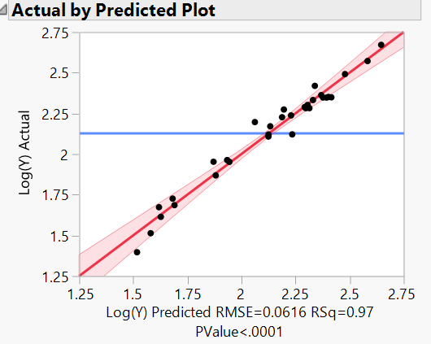

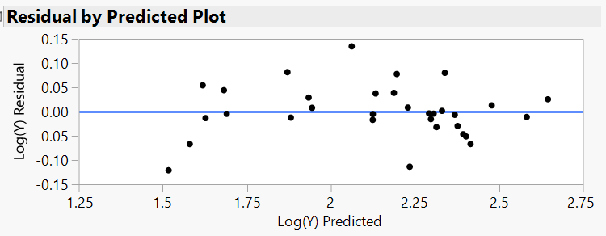

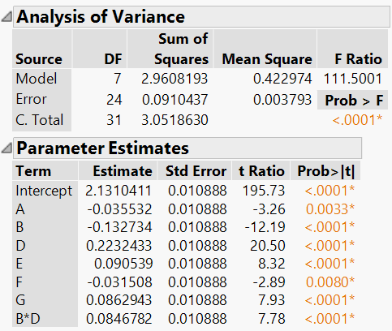

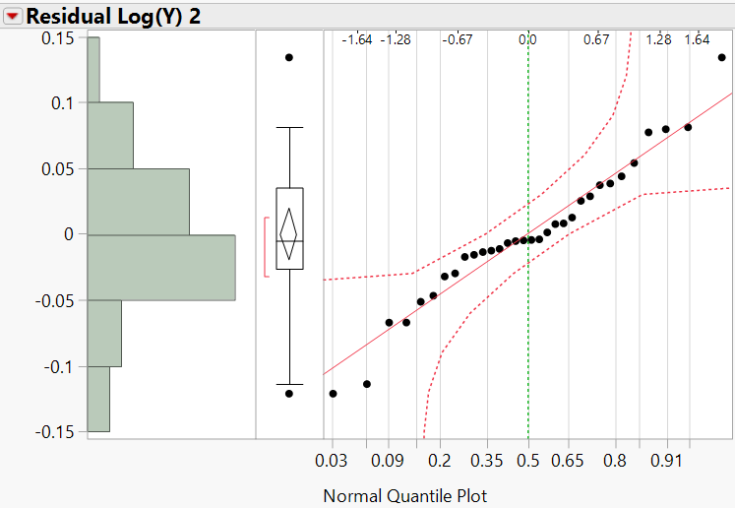

4.2.2 Combing initial fractional design and fold-over design

Even though the results of the follow-up experiment don’t match our expectation, we proceed to fit a model with combined data plus a block main effect since we conducted the initial fractional design and fold-over design on different days. In this design, the defining relation I=ABDEG.

Step 1: plot the response data

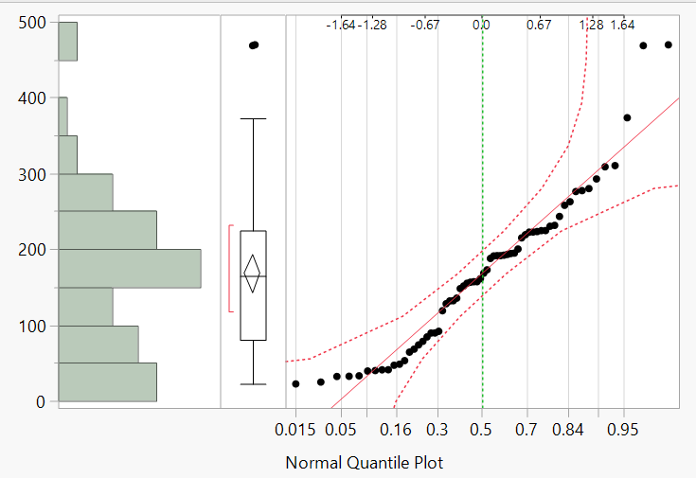

Since we are interested in higher values for yield, it could be understandable to fit a model for transformation that compresses value for low yield and spreads out the values for high yield. One reasonable choice would take log of yield as the new response. Here, we tried to take log transformation of Y to analyze the data and decided to analyze the reduced model with log Y.

Step 2: Fit a model with basic factors and use output to select a tentative reduced model

Since we combined initial fractional design and fold-over design together, there are 64 runs in the model within two blocks. Because there is no critical value for ME (marginal error) of 64 runs, I selected the significant terms in the normal plot and parameter estimate population, consulting with pareto diagram. Based on sparsity principle and hierarchy principle, the main effects A, B, C, D, E, F, G and two-factor interactions BD, CE will be included in the reduced model including block effect since ABDE=G.

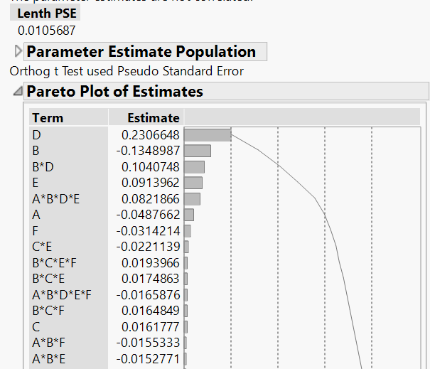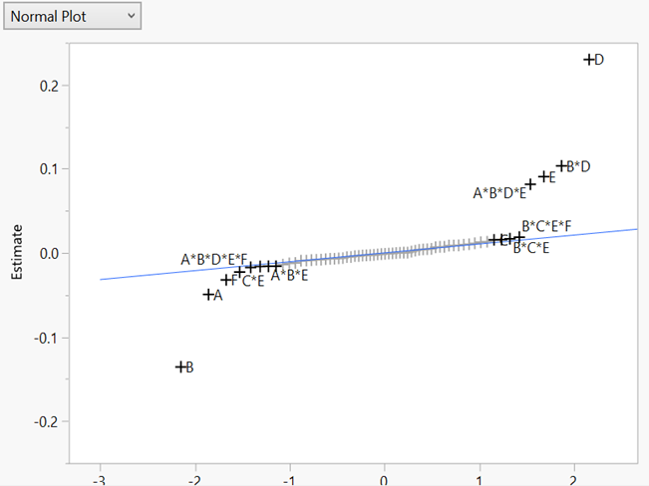

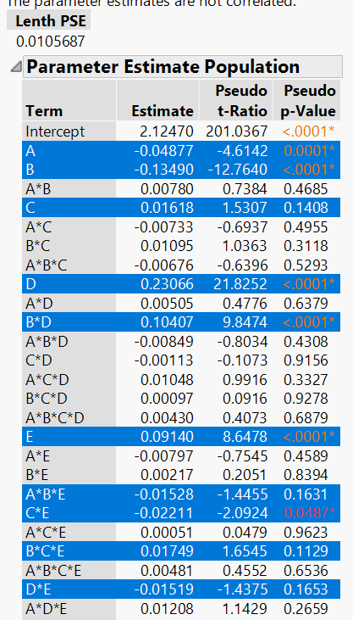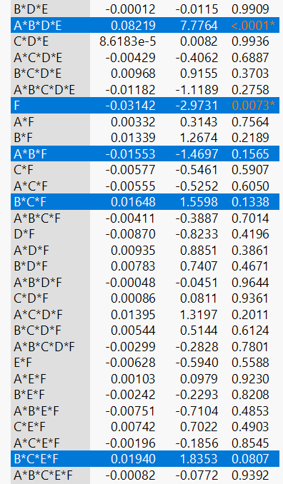

Step 3: Examine fit and diagnostics for the reduced model; consider modifications until a satisfactory summary is obtained.

This model has R2= 96%, which means 96% of the variability is explained by the estimates in the model. The ANOVA table tells us there is significant difference on mean of the log of yield. A residual versus predicted plot from this proposed reduced model indicates that the assumption of constant variability across the range of predicted responses appears good. Next, we plot residuals distribution to check on independence of the error distribution, which shows good. So, this reduced model appears to be satisfactory. From the parameter test table, it indicates that main effect C is still not significant in the model. Since two-factor interaction CE is important in the model, I will keep C in the model.

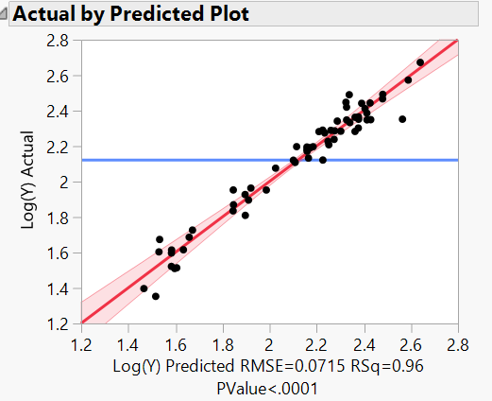

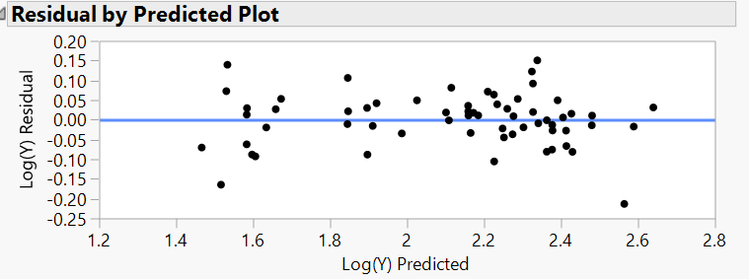

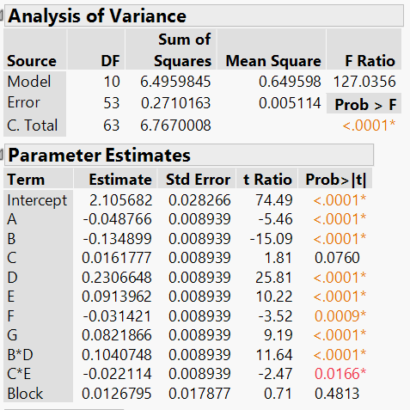

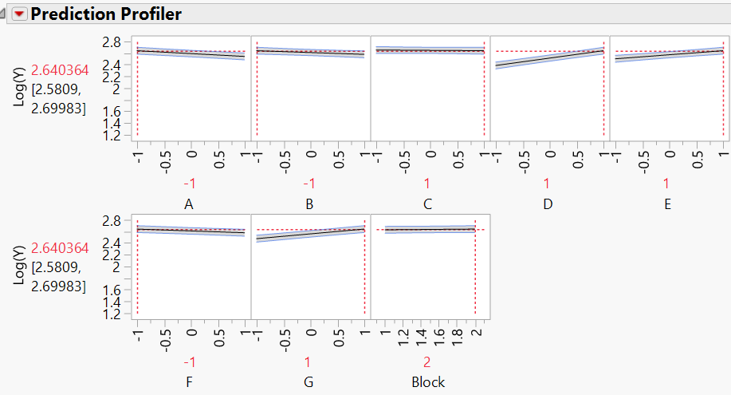

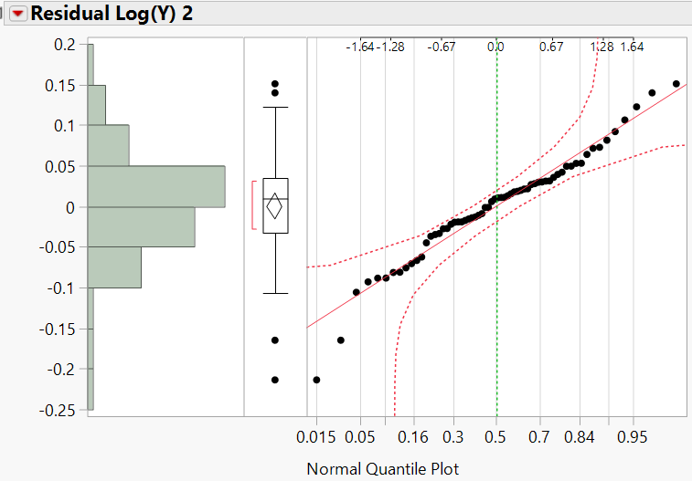

4.3 Compare the results above

Before folding After folding, combination with initial fractional design

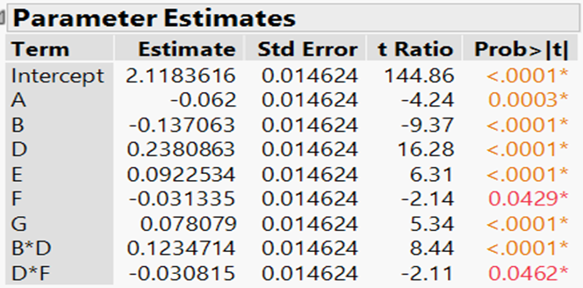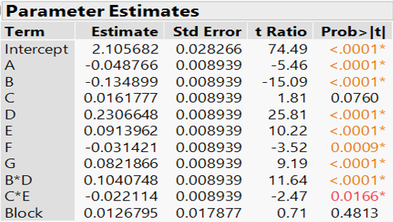

Using only the fold-over design

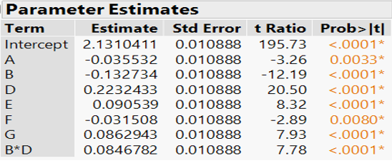

Compared to the results from initial fraction factorial design and the follow-up experiment that is additional 32 runs, we can see that the main effect estimates are unchanged. In the initial fractional design, DF is aliased with CE and we chose DF included in the model due to the hierarchy principle that D and F are significant parent factors in the model. Looking at the table from combined data, the two-factor interaction CE is significant and main effect C is not important in the model but we still keep C in the model.

**5. Conclusion**

From the final models above of three different fractional factorial design, changing main effects A, B and F from low level to high level respectively, the predicted values here that represent the expected Log(Y), averaging over the levels of the other factors will decrease. In other words, lowering the height of cup factor or rubber band or increasing the weight in catapult to launch will reduce the distance, other factors held constant. Main effects D, E and G increase the distance since we increase the tautness or angle or lift in higher level to launch. The main effect C that is the release pin in the catapult has no significant difference on the mean of predicted value because we set the level of C is from 3 to 4, which could be a possible reason.

**6. Recommend Settings**

Since setting the level from 3 to 4 for release pin has no much difference on predicted distance, we may need to increase the amplitude by altering the levels from 1 to 4 for the release pin. Alternatively, we could drop the insignificant main factor C to find new optimum region, that is to keep the release pin as fixed constant. We found out the fold-over design by switching column F didn’t match our expectation, which gives me the idea that we could consider adding a second fraction half the size of the first general fractional design called semi-folding.

**Reference**

Mee, R. (2009). A comprehensive guide to factorial two-level experimentation. Dordrecht; London: Springer.

**Appendix**

1. Initial Fractional Design



2. Fold-over design



3. Combined data with original fractional design and fold over design



